

Topic: PEFT Strategy Selection
Assesment:CO2-AT3
Name :Hemanth P
Reg.No:192472285

1.Introduction to Large Language Model Fine-Tuning

Large Language Models (LLMs) are pre-trained on huge amounts of text data and contain millions or billions of parameters. These models can be customized for specific applications through a process called fine-tuning.
Fine-tuning means training a pre-trained model using a specific dataset so that it performs better for a particular task.
For example, a company may customize an LLM for:
- Customer support
- Legal document analysis
- Medical applications
- Coding assistance
- Company-specific question answering
There are two important approaches for customization: Full Fine-Tuning and Parameter-Efficient Fine-Tuning (PEFT).

2. Full Fine-Tuning

Full fine-tuning is a method where all or nearly all parameters of the pre-trained LLM are updated using the company's training data.
For example, if an LLM contains 7 billion parameters, full fine-tuning attempts to update these parameters according to the new task.
Process:
Pre-trained LLM → Training Dataset → Forward Pass → Loss Calculation → Backpropagation → Update All Parameters → Fine-Tuned Model
The major advantage is that the model has maximum flexibility to learn the new task.
However, updating billions of parameters requires significant computational power and memory.

3. Problems with Full Fine-Tuning

Full fine-tuning is expensive because the training process requires memory for:
- Model parameters
- Gradients
- Optimizer states
- Activations
- Intermediate computations
It also requires powerful GPUs and longer training time.
Major limitations:
High Memory Usage: Large models require substantial GPU memory.
High Computational Cost: Calculations are performed for a huge number of parameters.
Long Training Time: Training all parameters takes longer.
High Storage Requirement: Every customized version can require storing another large model.
Therefore, full fine-tuning may not be suitable for a company with limited resources.

4. Parameter-Efficient Fine-Tuning (PEFT)

- PEFT stands for Parameter-Efficient Fine-Tuning.
- PEFT is designed to customize large models without updating all their parameters.
- The main idea is to:
- Freeze most of the original model parameters and train only a small number of additional or selected parameters.
- Instead of modifying billions of parameters, PEFT modifies only a small portion.
- Basic process:
- Pre-trained LLM → Freeze Base Model → Add Trainable Parameters → Train Small Parameters → Customized LLM
- This reduces the computational and memory requirements significantly.

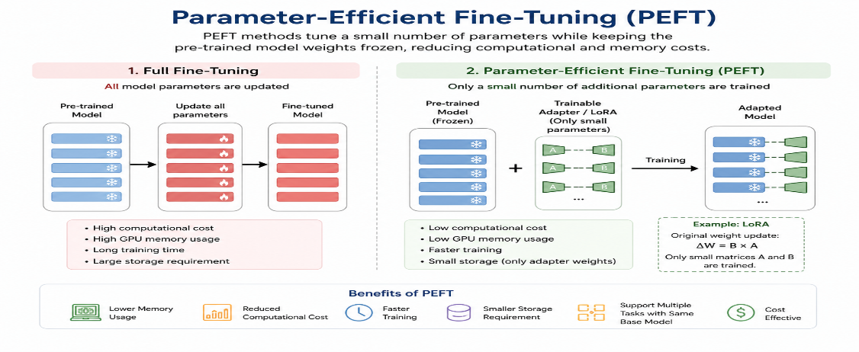
5. LoRA – Low-Rank Adaptation

LoRA stands for Low-Rank Adaptation.
It is one of the most popular PEFT techniques for LLM customization.
In LoRA, the original model parameters are frozen. Instead of directly changing the original weights, LoRA adds small trainable matrices to selected layers.
The basic concept can be represented as:
W' = W + ΔW
Where:
- W = Original model weights
- ΔW = Weight update
- W' = Adapted weights
LoRA represents the weight update using two small matrices:
ΔW = B × A
Only A and B are trained, while the original W remains frozen.

6. How LoRA Works
Suppose the model contains a very large weight matrix.
In full fine-tuning, the complete matrix is updated:
Large Weight Matrix → Calculate Gradients → Update Entire Matrix
In LoRA:
Large Weight Matrix → Freeze It → Add Small Matrices → Train Small Matrices
For example, suppose a layer has a weight matrix of:
4096 × 4096
This contains:
16,777,216 parameters
If LoRA uses a low rank of 8, it can use two much smaller matrices:
A = 8 × 4096
B = 4096 × 8
Therefore, only:
65,536 parameters
are trained for this update instead of the entire 16.7 million parameters.
This demonstrates why LoRA is computationally efficient.
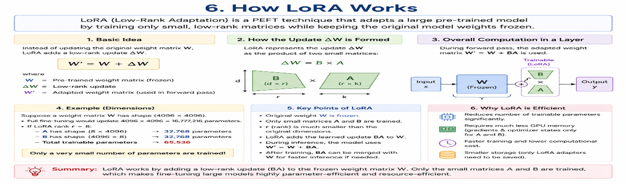

7. Full Fine-Tuning vs PEFT/LoRA

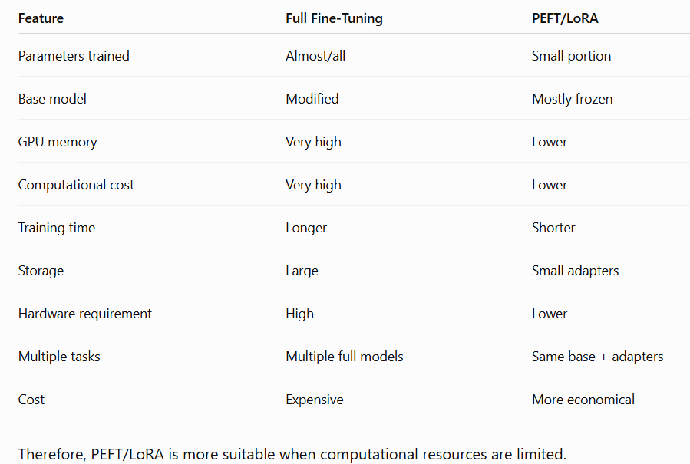

8. How PEFT/LoRA Reduces Computational Requirements

In full fine-tuning, gradients and parameter updates are calculated for a very large number of parameters.
In LoRA, only the small trainable adapter parameters require optimization.
This reduces:
- Number of trainable parameters
- Gradient calculations
- Optimizer calculations
- Training workload
- GPU requirements
- Training cost
The model still uses the original base model during forward processing, but the expensive parameter-update process is limited to the small LoRA components.
Therefore, LoRA makes fine-tuning more computationally efficient.

9. How PEFT/LoRA Reduces Memory and Storage

Memory is another major advantage of LoRA.
Full fine-tuning requires memory for the model weights, gradients, and optimizer states for a huge number of trainable parameters.
LoRA keeps the original model weights frozen. Therefore, gradients and optimizer states are required mainly for the small LoRA parameters.
LoRA also reduces storage requirements.
For example:
Full Fine-Tuning:
Base Model → Complete Customized Model
LoRA:
Base Model + Small LoRA Adapter → Customized Model
The same base model can be used with different adapters for different tasks.
For example:
One Base LLM
→ Customer Support LoRA
→ Legal LoRA
→ Finance LoRA
→ Medical LoRA
This makes LoRA highly useful for companies that need multiple customized applications.

Got it 👍 You want 10 main topics, but each topic should have enough detailed content like the first answer—not just short points.
PEFT Strategy Selection – 10 Main Topics
1. Introduction to Large Language Model Fine-Tuning
Large Language Models (LLMs) are pre-trained on huge amounts of text data and contain millions or billions of parameters. These models can be customized for specific applications through a process called fine-tuning.
Fine-tuning means training a pre-trained model using a specific dataset so that it performs better for a particular task.
For example, a company may customize an LLM for:
- Customer support
- Legal document analysis
- Medical applications
- Coding assistance
- Company-specific question answering
There are two important approaches for customization: Full Fine-Tuning and Parameter-Efficient Fine-Tuning (PEFT).

2. Full Fine-Tuning
Full fine-tuning is a method where all or nearly all parameters of the pre-trained LLM are updated using the company's training data.
For example, if an LLM contains 7 billion parameters, full fine-tuning attempts to update these parameters according to the new task.
Process:
Pre-trained LLM → Training Dataset → Forward Pass → Loss Calculation → Backpropagation → Update All Parameters → Fine-Tuned Model
The major advantage is that the model has maximum flexibility to learn the new task.
However, updating billions of parameters requires significant computational power and memory.

3. Problems with Full Fine-Tuning
Full fine-tuning is expensive because the training process requires memory for:
- Model parameters
- Gradients
- Optimizer states
- Activations
- Intermediate computations
It also requires powerful GPUs and longer training time.
Major limitations:
High Memory Usage: Large models require substantial GPU memory.
High Computational Cost: Calculations are performed for a huge number of parameters.
Long Training Time: Training all parameters takes longer.
High Storage Requirement: Every customized version can require storing another large model.
Therefore, full fine-tuning may not be suitable for a company with limited resources.

4. Parameter-Efficient Fine-Tuning (PEFT)
PEFT stands for Parameter-Efficient Fine-Tuning.
PEFT is designed to customize large models without updating all their parameters.
The main idea is to:
Freeze most of the original model parameters and train only a small number of additional or selected parameters.
Instead of modifying billions of parameters, PEFT modifies only a small portion.
Basic process:
Pre-trained LLM → Freeze Base Model → Add Trainable Parameters → Train Small Parameters → Customized LLM
This reduces the computational and memory requirements significantly.

5. LoRA – Low-Rank Adaptation
LoRA stands for Low-Rank Adaptation.
It is one of the most popular PEFT techniques for LLM customization.
In LoRA, the original model parameters are frozen. Instead of directly changing the original weights, LoRA adds small trainable matrices to selected layers.
The basic concept can be represented as:
W' = W + ΔW
Where:
- W = Original model weights
- ΔW = Weight update
- W' = Adapted weights
LoRA represents the weight update using two small matrices:
ΔW = B × A
Only A and B are trained, while the original W remains frozen.

6. How LoRA Works
Suppose the model contains a very large weight matrix.
In full fine-tuning, the complete matrix is updated:
Large Weight Matrix → Calculate Gradients → Update Entire Matrix
In LoRA:
Large Weight Matrix → Freeze It → Add Small Matrices → Train Small Matrices
For example, suppose a layer has a weight matrix of:
4096 × 4096
This contains:
16,777,216 parameters
If LoRA uses a low rank of 8, it can use two much smaller matrices:
A = 8 × 4096
B = 4096 × 8
Therefore, only:
65,536 parameters
are trained for this update instead of the entire 16.7 million parameters.
This demonstrates why LoRA is computationally efficient.

7. Full Fine-Tuning vs PEFT/LoRA
Feature | Full Fine-Tuning | PEFT/LoRA
Parameters trained | Almost/all | Small portion
Base model | Modified | Mostly frozen
GPU memory | Very high | Lower
Computational cost | Very high | Lower
Training time | Longer | Shorter
Storage | Large | Small adapters
Hardware requirement | High | Lower
Multiple tasks | Multiple full models | Same base + adapters
Cost | Expensive | More economical
Therefore, PEFT/LoRA is more suitable when computational resources are limited.

8. How PEFT/LoRA Reduces Computational Requirements
In full fine-tuning, gradients and parameter updates are calculated for a very large number of parameters.
In LoRA, only the small trainable adapter parameters require optimization.
This reduces:
- Number of trainable parameters
- Gradient calculations
- Optimizer calculations
- Training workload
- GPU requirements
- Training cost
The model still uses the original base model during forward processing, but the expensive parameter-update process is limited to the small LoRA components.
Therefore, LoRA makes fine-tuning more computationally efficient.

9. How PEFT/LoRA Reduces Memory and Storage
Memory is another major advantage of LoRA.
Full fine-tuning requires memory for the model weights, gradients, and optimizer states for a huge number of trainable parameters.
LoRA keeps the original model weights frozen. Therefore, gradients and optimizer states are required mainly for the small LoRA parameters.
LoRA also reduces storage requirements.
For example:
Full Fine-Tuning:
Base Model → Complete Customized Model
LoRA:
Base Model + Small LoRA Adapter → Customized Model
The same base model can be used with different adapters for different tasks.
For example:
One Base LLM
→ Customer Support LoRA
→ Legal LoRA
→ Finance LoRA
→ Medical LoRA
This makes LoRA highly useful for companies that need multiple customized applications.

10. Recommendation and Conclusion
For the given scenario, PEFT with LoRA is the most appropriate approach.
The company cannot afford to update all model parameters. Therefore, full fine-tuning would require excessive GPU memory, computational resources, training time, and storage.
LoRA solves this problem by keeping the original model parameters frozen and training only a small number of low-rank adapter parameters.
Final Recommendation:
PEFT + LoRA should be selected because it:
- Reduces trainable parameters
- Reduces GPU memory requirements
- Reduces computational cost
- Reduces training time
- Reduces storage requirements
- Allows multiple task-specific customizations
- Provides a cost-effective way to customize large LLMs

Conclusion:
For a company with limited computational and financial resources, PEFT/LoRA provides the best balance between customization, performance, memory efficiency, and cost, making it preferable to full fine-tuning.

BY:
HEMANTH P
192472285

